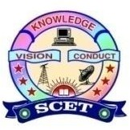

Event no: VII
Title of the Activity
Workshop on PCB Design
Type of Activity
Hands-on Technical Workshop under AICTE IDEA Lab
Organizing Unit
AICTE IDEA Lab and Department of ECE
Date & Venue
- Date: 18/12/2025
- Venue: AICTE IDEA Lab
Objective of the Activity
The objective of the Workshop on PCB Design was to:
- Provide practical exposure to printed circuit board (PCB) design concepts
- Train students in schematic design, PCB layout, and fabrication basics
- Enable students to design PCBs for IDEA Lab-based prototypes and projects
- Bridge the gap between theoretical electronics and real-world product development
Participants
- Students from EEE, ECE, and related branches
- Faculty members and IDEA Lab coordinators
Description of the Activity
As part of Event No. 6 under the AICTE IDEA Lab initiative, a hands-on workshop on PCB design was conducted at Swarnandhra College of Engineering & Technology. The workshop covered fundamentals of PCB design, schematic capture, component selection, layout rules, and design for manufacturability. Participants were trained using industry-relevant PCB design software and were guided through the complete process from circuit concept to PCB layout. The session emphasized the role of PCB design in developing functional prototypes within the AICTE IDEA Lab.

Role of AICTE IDEA Lab
- Provided state-of-the-art facilities and tools for hands-on learning
- Enabled experiential learning through design and prototyping
- Supported interdisciplinary and application-oriented skill development
- Facilitated conversion of ideas into working electronic prototypes
Outcomes of the Activity
- Enhanced technical skills in PCB schematic and layout design
- Improved understanding of electronics product development workflow
- Enabled students to design PCBs for projects, prototypes, and startups
- Increased utilization of AICTE IDEA Lab infrastructure
- Prepared students for industry and entrepreneurial applications
Impact
The workshop significantly strengthened students’ practical electronics and design skills, enabling them to develop reliable hardware solutions and reinforcing the importance of hands-on learning promoted by the AICTE IDEA Lab.
Conclusion
The Workshop on PCB Design successfully met the objectives of the AICTE IDEA Lab Scheme by promoting experiential learning, technical competency, and innovation-driven skill development. Such workshops play a vital role in empowering students to transform ideas into functional hardware solutions.
Gallery
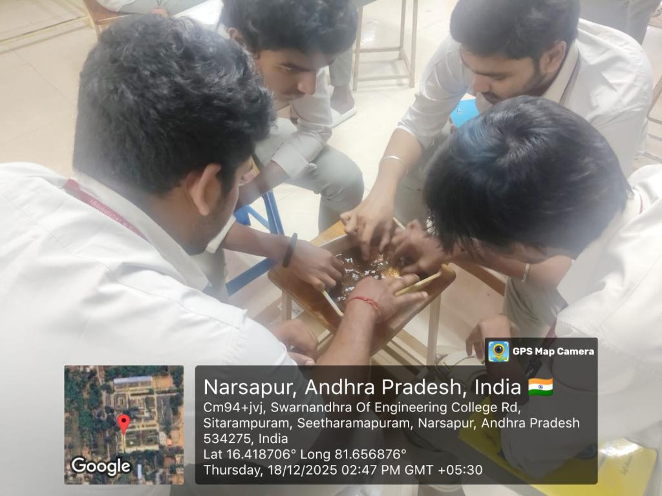 | 